MZUZU UNIVERSITY
ICT 1101 – END USER COMPUTING ASSESSMENT 2
Answer All Questions Time Allowed 1.5 hrs

SECTION A

- The following is a screen shot of one of the Microsoft programs.
  - Fill the missing parts(a-d) in this diagram: (4 marks)

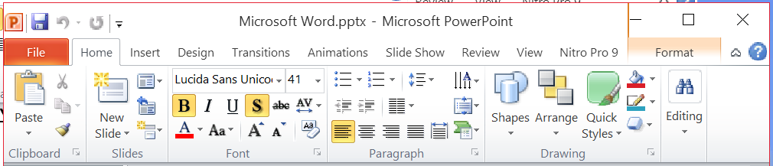
a

d
c
b

a dialog box launcher
b groups
c tabs
d minimize the ribbon button

  - What Microsoft program is this and what does it do? ( 2 marks)
Powerpoint—
Making presentations
- Explain the uses of the following in Microsoft Office 2010 (10 marks)
  - Powerpoint notes pane
where you type speaker notes that you can refer to when you present
  - Title bar
displays the name of the active document
  - Quick access toolbar
These are buttons for any command to which the user wants to have easy access
  - Status bar
displays information about the current file and provides access to certain program functions.
  - Excel Formula bar
A place where you can enter or view formulas or text.

- Explain 4 commands available in Backstage view of Powerpoint (8 marks)
The Recent page displays the names of the presentations you recently worked on.
The New page displays all the templates on which you can base a new presentations.
The Print page displays all print-related commands and provides a pane for previewing the current presentation as it will appear when printed.
The Share page displays all the commands related to making the current presentation available to other people
The Help page displays all the ways you can get help and support

- Explain any 3 views available in Word (6 marks)
Print Layout view :This view displays a document on the screen the way it will look when printed
Full Screen Reading view This view displays as much of the content of the document as will fit on the screen at a size that is appropriate for reading
Web Layout view This view displays the document the way it will look when viewed in a Web browser
Outline view This view displays the structure of a document
Draft view This view displays the content of a document with a simplified layout so that you can type and edit quickly

- Explain any 3 print layouts available in Powerpoint (6 marks)
Full Page Slides – print out with each slide on a full page
Handouts - print out with up nine slides per page
Notes Page - print out of one slide per page including any notes you may have added in the Notes Pane while creating your presentation
Outline View - print out of your text from all of your slides in an outline format.

- Describe how the following can be accomplished in Microsoft word (8 marks)
  - Select the whole paragraph
Triple-click anywhere in the paragraph
Or
Double-click in the selection area to the left of the paragraph.

  - Select the entire document
Triple-click in the selection area.
Ctrl + A

  - Apply a background of yellow to the page
PAGE LAYOUT PAGE BACKGROUND GROUPPAGE COLORCHOOSE YELLOW
  - Save a file
FILESAVE AS/SAVE
CTRL+S
- What is the use of the following operators in Microsoft Excel? (6 marks)
  - = Begins all Excel functions and formulas
  - > greater than
  - / division
  - + Addition
  - * Multiplication
  - <= Less than or equal to
SECTION B
- Carefully look at a spreadsheet below: (25 marks)

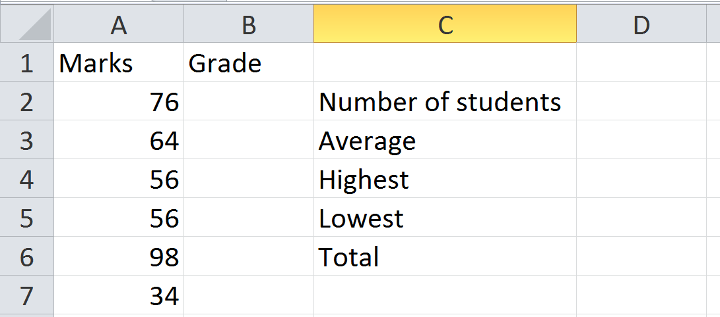
  - In cell D2, write a formula to display the total number marks that have been recorded in A2:A7
=count(A2:A7) 3 marks
  - In cell D3, write a formula to display the average of all the marks in A2:A7.
=AVERAGE(A2:A7) 3 marks
  - In cell D4, write a formula to display the highest mark from all of the marks in A2:A7.
=max(A2:A7) 3 marks
  - In cell D5, write a formula to display the lowest mark from all of the marks in A2:A7.
=min(A2:A7) 3 marks
  - In cell D6, write a formula to display the sum of all the marks in A2:A7.
=sum(A2:A7) 3 marks
  - In cell B2, write a formula to display the grade corresponding to the marks according to the following 8 marks
Less than 50 is grade F,
Greater than or equal to 50 but less than 80 is grade B
Greater than or equal to 80 is grade A
=IF(A2>=80, “A”,IF(A2>=50, “B”, “F”))
OR
=IF(A2<50, “F”,IF(A2<80, “B”, “A”))
  - How can one copy the formula from cell B2 to the other cells below it?
Autofill function 2 marks

- Carefully look at the slide below: (25 marks)
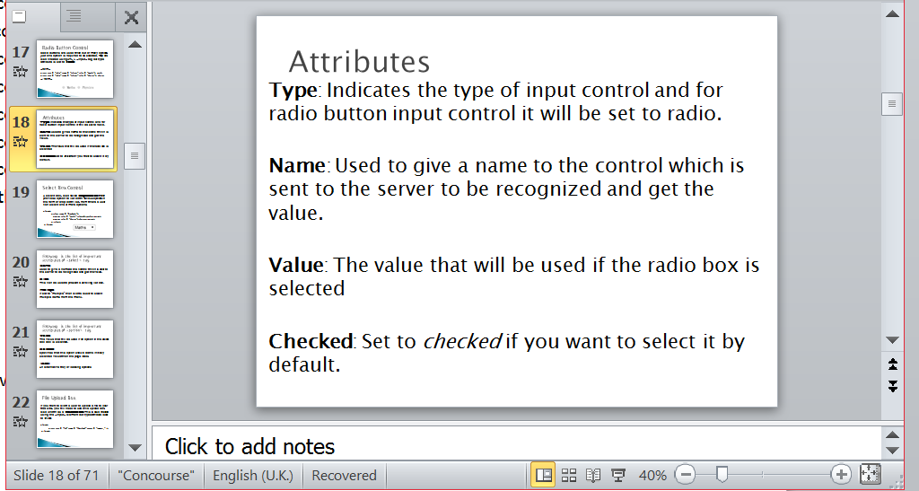
  - Explain how animations for entrance can be added to each paragraph on this slide. Animations should start only when a mouse has been clicked.

Select each paragraph one at at a time
Animation tab
Animation group/Advanced Animation Group
Select Animation
Entrance Group
Timing
-start-
on mouse

  - Explain how you can add transitions to make s slide. The transition should last 5 seconds and make sounds.

Select the slide
Transitions tab
“transition to this slide” group
Choose the transition under
“Timing” group
Duration -
type “05:00”
Sounds—>
chose a sound effect
  - The presenter wants to use slide show view for the presentation of all slides. Explain how this can be achieved.
Slide show tab
Start Slide show group
From beginning
  - The user wants to print all slides. But he wants to have 6 slides on each A4 paper. Explain how this can be achieved.
Fileprint (ctrl + P)
Settings
Print layout
6 handouts
Print

End of Question Paper

